9-sinf Texnika A Matematika
1. Agar $a, b, c$ musbat haqiqiy sonlar uchun $a∙b=14$ va $b∙c=6$bo’lsa
$a+2b+3c$ ning eng kichik qiymatini toping.
A) 34 B) 16 C) 20 D)18
2. $\left(24;\left.204\right]\right.$ oraliqda 3ga karrali bo’lgan barch natural sonlar yig’indisi qanday raqam bilan tugaydi?
A) 5 B) 6 C) 0 D) 2
3. 12 qatordan iborat bo’lgan musiqa zalining birinchi qatorida 28 ta o’rindiq bor. Keyingi har bir qatordagi o’rindiqlar soni oldingi qatordagidan 4 taga ko’p. Musiqa zalida jami nechta o’rindiq bor?
A) 600 B) 612 C) 576 D) 504
4. ${\left(x^{3}-\frac{1}{x^{2}}\right)}^{10}$ ifoda yoyilmasida boshidan nechanchi hadi ozod son bo’ladi?
A) 6 B) 7 C) 8 D) 9
5. $3^{50}, { 3}^{48}, 3^{46}…$progressiyaning nechanchi hadidan boshlab uning hadlari 1 dan kichik sonlar bo’ladi?
A) 25 B) 26 C) 27 D) 28
6. $x$ uchun quyidagi $0<x^{3}<x$ shart berilgan bo’lsa, $a=\frac{1}{x}, b=\frac{1}{\sqrt[2]{x}}, c=\frac{1}{x^{2}}$ lar uchun qaysi javob to’g’ri?
A) $a<b<c$ B) $c<b<a$
C) $c<a<b$ D) $b<a<c$
7. $2x^{2}-2ax+1=0$ kvadrat tenglama ildizlari uchun
${\left(\frac{2x_{1}}{x_{1}+x_{2}+1}\right)}^{2}+{\left(\frac{2x_{2}}{x_{1}+x_{2}+1}\right)}^{2}=3$ tenglik o’rinli bo’lsa, $a$ ni qiymatini toping.
A) 1 B) -3 C) -1 D) 7
8. $a$ va $b$ natural sonlar, $\frac{1}{a}+\frac{1}{b}=\frac{6}{x}$ va $a+b=18$ tenglikni qanoatlantirsa, $x$ ning eng katta qiymatini toping.
A) 15 B) 31 C) 24 D) 27
9. $A$ sonini 12 ga bo’lganda 10 qoldiq qoladi. $A^{5}+A^{3}+1$ yig’indini 6ga bo’lgandagi qoldig’ini toping.
A) 0 B) 1 C) 2 D) 3
10. Hisoblang.
$$\sqrt{{2003}^{2}+{2003}^{2}∙{2004}^{2}+{2004}^{2}}-{2003}^{2}$$
A) 2003 B) 2002 C) 2005 D) 2004
11. $x=\sqrt{7}-\sqrt{5}, y=\sqrt{5}-\sqrt{3}$ va
$z=\sqrt{3}-\sqrt{7}$ bo’lsa,
$x^{3}+y^{3}+z^{3}-2xyz$ ni hisoblang.
A) 0 B) $2\sqrt{7}+2\sqrt{3}-4\sqrt{5}$
C) 1 D) $4\sqrt{7}+4\sqrt{3}-2\sqrt{5}$
12. Agar $x$ va $y$ raqamlar bo’lsa,
$4x+\frac{3}{8}y=36$ tenglik bajarilsa $4x+y$ ning qiymatini toping.
A) 41 B) 27 C) 36 D)40
13. Hisoblang.
$$\frac{1}{1+2+…+5}+\frac{1}{1+2+…+6}+…+\frac{1}{1+2+…+14}$$
A) $\frac{1}{3}$ B) $\frac{2}{3}$ C) $\frac{4}{15}$ D) $\frac{2}{15}$
14. $\frac{3}{\sqrt[3]{5}-\sqrt[3]{2}}$ kasr maxrajini irratsionallikda qutqaring.
A) $\sqrt[3]{25}-\sqrt[3]{4}$ B) $\sqrt[3]{5}+\sqrt[3]{2}$
C) $\sqrt[3]{25}-\sqrt[3]{2}$ D) $\sqrt[3]{25}+\sqrt[3]{10}+\sqrt[3]{4}$
15. $x^{3}+ax^{2}-bx-27=0$ tenglamaning ildizlari geometrik progressiya tashkil qiladi. $a$ ning $b$ ga nisbatini toping.
A) $-\frac{2}{3}$ B) $-\frac{1}{3}$ C) $\frac{1}{3}$ D) $\frac{4}{3}$
16. $x$ haqiqiy sonlar uchun
$x\sqrt{x}-2018\sqrt{x}=2017$ tenglik o’rinli bo’lsa, $x-\sqrt{x}-1923$ ifodaning qiymatini toping.
A) 95 B) 94 C) 90 D) 84
17. $M=\underset{12}{\underbrace{999…9}}$ va $N=372$ sonlari ko’paytmasining raqamlari ig’indisini toping.
A) 99 B) 108 C) 117 D) 126
18. Hisoblang.
$$\frac{100}{99}+\frac{100∙98}{99∙97}+\frac{100∙98∙96}{99∙97∙95}+…+\frac{100∙98∙96∙…∙4∙2}{99∙97∙95∙…∙3∙1}$$
A) 99 B) 100 C) 9900 D) 10000
19. Agar ushbu $\frac{80!}{8^{n}}$ ifoda butun son bo’lsa, $n$ eng ko’pi bilan necha bo’ladi?
A) $26$ B) $25$ C) $20$ D) $22$
20. Har birining balandligi $18$ sm bo’lgan yetita qutining beshtasi arzimas qalinlikdagi va polga parallel ravishda stolga, ikkitasi rasmdagi kabi stol ostidagi polga joylashtirilgan.
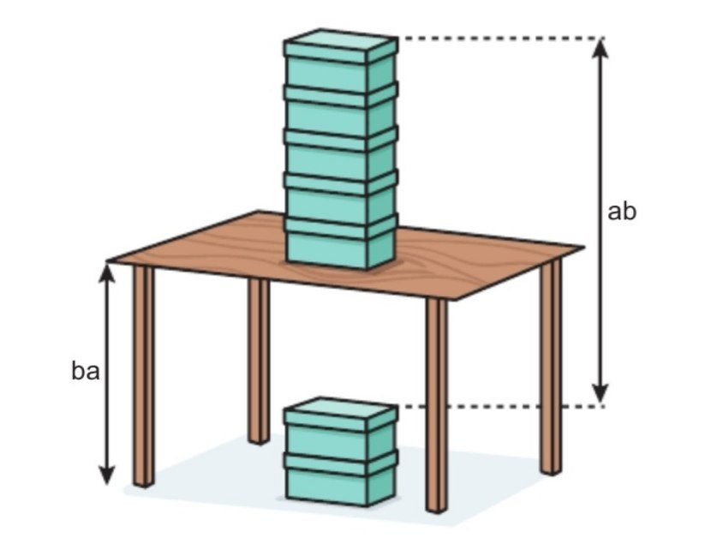
Bunga ko’ra, $\overline{ba}$ necha sm bo’ladi?
A) $47$ B) $39$ C) $69$ D) $29$
21. $\left|2x-7\right|≤1$ tengsizlik nechta natural yechimga ega?
A) $4$ B) $1$ C) $2$ D) $3$
22. Agar ushbu $ax^{4}+bx^{3}+cx^{2}+dx+e=\left(x^{2}-1\right)\left(px^{2}+qx+r\right)+2x-1$ tenglik o’rinli bo’lsa, $a+c+e$ ni toping.
A) $-2$ B) $-1$ C) $0$ D) $1$
23.
$\frac{1}{6}\left(\frac{1}{5}\left(\frac{1}{4}\left(\frac{1}{3}\left(\frac{1}{2}\left(x+2\right)+2\right)+3\right)+4\right)+5\right)=2$ tenglamaning ildizlari yig’indisini toping.
A) $1$ B) $0$ C) $720$ D) $2160$
24. EKUB i $12$ ga, EKUK i $240$ ga teng bo’lgan $2$ ta sondan bittasi $60$ ga teng. Bu sonlarning ikkinchisini toping.
A) $40$ B) $48$ C) $72$ D) $36$
25. Agar ${\left(a^{3}-2b^{2}\right)}^{5}=…+n∙a^{9}∙b^{4}+…$ bo’lsa, $n$ ni toping.
A) $10$ B) $20$ C) $40$ D) $60$
26. $P\left(x\right)$ ko’phadni $x^{2}-5x+6$ ga bo’lganda, qoldiq $3x-4$ bo’ladi. $P\left(x\right)$ ko’phadni $x-3$ ga bo’lgandagi qoldiqni toping.
A) $x+3$ B) $-4$ C) $5$ D) $4$
27. $\left(x+1\right)\left(x+2\right)\left(x+3\right)\left(x+4\right)=25$ tenglamani haqiqiy ildizlari yig’indisini toping.
A) $-10$ B) $5$ C) $10$ D) $-5$
28. $25x^{4}={(3x^{2}+4x)}^{2}$ tenglama nechta turli haqiqiy ildizga ega?
A) $2$ B) $3$ C) $4$ D) $1$
29. Agar ushbu $\frac{5x+1}{x^{2}-x-12}=\frac{a}{x+3}+\frac{b}{x-4}$ tenglik ayniyat bo’lsa, $b-a$ ni toping.
A) $-1$ B) $6$ C) $1$ D) $-6$
30. Ushbu $\left\{\begin{aligned}7x-3y+5z=32 \\ 5x+2y+z=11 \\ 2x-y+3z=14 \end{aligned} \right.$tenglamalar sistemasidan foydalanib, $x+y+z$ ni toping.
A) $2$ B) $1$ C) $4$ D) $3$

